FEDERAL GOVERNMENT GIRLS’ COLLEGE UMUAHIA 2023/2024 THIRD TERM SS2 HOLIDAY PROJECT.
SS2 FISHERY HOLIDAY PROJECT
(1) Give a detailed explanation of mariculture (2) draw and label inboard an outboard canoe
SS2 AGRIC: Agric students are to bring five fingerlings of fish each.
SS2 CRS
1a. Trace the circumstances that led to the death of Ananias and sapphira.
1b. Indicate two lessons that could be drawn from this incident.
SS 2 HEALTH SCIENCE
1.Define Environmental health
2.Explain any 4 non communicable diseases you know

SS2 GEOGRAPHY
INSTRUCTION: To be submitted the first week of resumption immediately after first assembly through the subject teacher.
1.Each(the) student must buy WEST AFRICAN MAP READING TEXTBOOK BY D.A NIMAKO. Published by Longman Latest Edition. The student should check the inside map for clarity of maps .take note
2. Thread and maset. The student must present item 1&2 before she would be allowed into the
classroom for lession.
3.meaning of Geographic information system
4. Application of Geographic information system (GIS)
5.common pitfalls of GIS implementation strategy
6.Problems of GIS implementation in Nigeria.

SS2 HOLIDAY PROJECT.
No 1: Define the following terms; (i) Vector quantities. (ii) Scalar quantities. No 2: list three examples of each quantity defined above.

COMMERCE SS 2
1 what is law of agency
State five rights of a principal and five rights of an agent

SS2 ECONS
1a. What is circular flow of income?
b. Use a diagram to illustrate circular flow of income.
2. Explain the following and state their formula.
a. Average propensity to consume (APC)
b. Marginal propensity to consume (MPC)
c. Concept of the multiplier (M)
TECHNICAL DRAWING SS 2. HOLIDAY PROJECT
1. The figure below shows the front elevation of a right cone.
A) Copy the given view
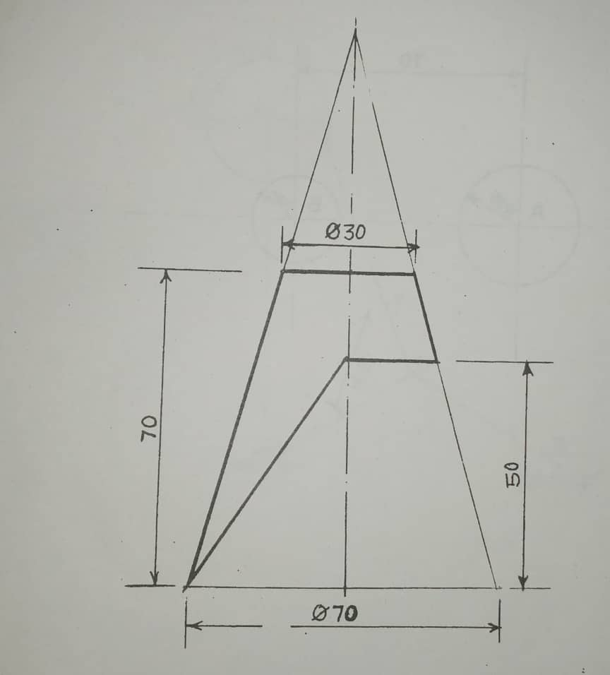
B) Draw the pattern development of the right cone.

Note: All measurements are in millimeters.

SS2 ENGLISH LANGUAGE
INSTRUCTIONS:
i. Do this exercise in your CAT or BOTT exercise book.
ii. Write very neatly; cross your t’s and dot your i’s.
iii. Leave a line after each answer and do not jam your words together.
iv. Ensure that you date your work at the right hand side of your note.
In a tabular form, write down the exact words that rhyme with the following ten words. Example: lord - laud.
mayor, him, colonel, wait, hoarse, flaw, boar, suite, gaol, air.

SS2 COMPUTER
- Write short note on the stages of SDLC
- Explain the term, program development
SS2 DATA PROCESSING
- Using Microsoft PowerPoint, create a presentation of not less than 12 slides on the topic “The importance of Interactive Smartboard in teaching and learning”
- Apply the necessary designs, images, effects, etc.
- Package your presentation into a CD or using your own email, forward your presentation to sirjoe9817@gmail.com
SS2 LITERATURE-IN-ENGLISH
INSTRUCTIONS:
i. Do this exercise in your CAT or BOTT exercise book.
ii. Write very neatly; cross your t’s and dot your i’s.
iii. Leave a line after each answer and do not jam your words together.
iv. Ensure that you date your work at the right hand side of your note.
v. Copy the prose and questions and write your answers in the blank spaces.
UNSEEN PROSE
Why did Africa let Europe cart away millions of Africa’s souls from the continent to the four corners of the wind? How could Europe lord it over a continent ten times it’s size? Why does needy Africa continue to let it’s wealth meet the needs of those outside its borders and then follow behind with hands outstretched for a loan of the very wealth it let go? How did we arrive at this, that the best leader is the one that knows how to beg for a share of what he has already given away at the price of a broken tool?
Where is the future of Africa?
QUESTIONS
1. The dominant device used in the passage is..................
(a) rhetorical question (b) monologue
(c) question tag (d) reported speech
2. Four corners of the wind is a......................
(a) figurative device (b) dramatic device
(c) rhetorical device (d) class of speech
3. ‘Price of a broken tool’ as used in the passage is what figure of speech?
(a) oxymoron (b) metaphor (c) imagery (d) euphemism
4. The dominant mood in the passage is
(a) despair (b) anger (c) worry (d) sadness
5. A poem written to mourn the dead is called ................
(Supply the answer by yourself)
SS2 CIVIC EDUCATION
- Responsible parents have divert roles to play in the lives of their children. Discuss any five of those roles.

